

Why volunteer?
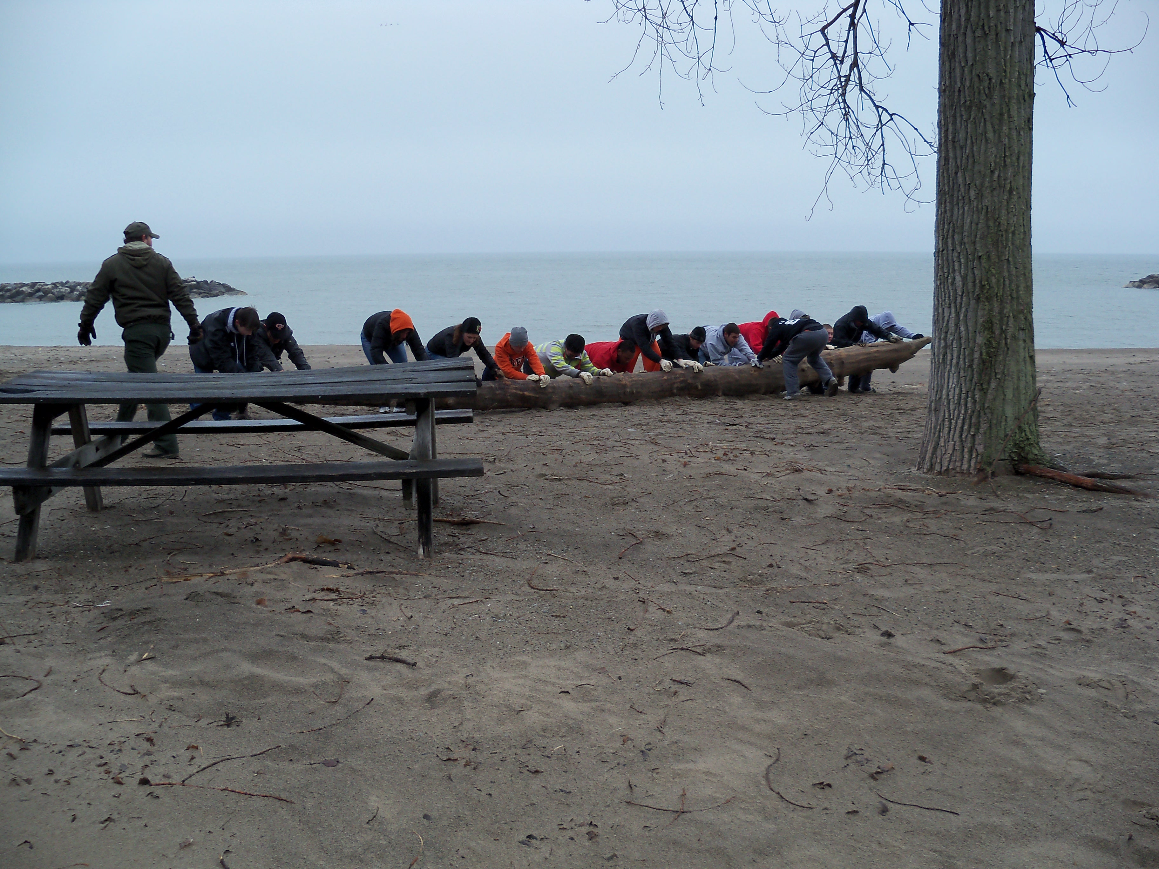

Become a DCNR Conservation Volunteer

The volunteers of Presque Isle and Erie Bluffs State Park Complex play a vital role in the day-to-day functions of the complex. From greeting our 4 million guests a year to leading interpretive pontoon boat tours through the lagoons, our volunteers can get as involved as they choose.

Presque Isle is the most visited state park in the state and the PA DCNR State Park system was voted the #1 system in the country in 2011.

Volunteers receive the necessary training to perform their tasks and are introduce to new areas of interest through our quarterly meeting/trainings and monthly volunteer newsletter.

Many of the volunteers enjoy the social aspect of volunteering and look forward to their time at the park. Many friendships have developed through volunteering.

Volunteers under the age of 18 must be accompanied by an adult.

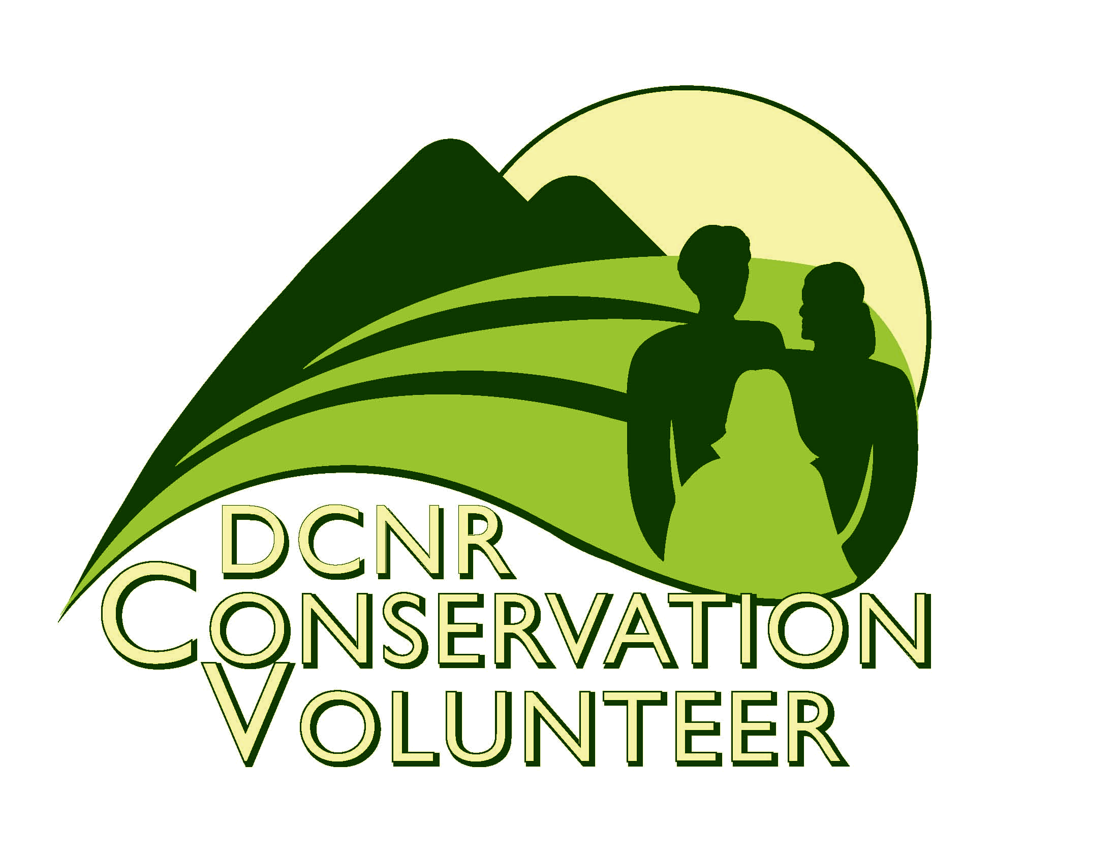
For more information on DCNR Conservation Volunteer Program please visit:
https://www.volunteers.dcnr.state.pa.us/index.aspx

Complete the online application or contact the volunteer coordinator for an application.

Presque Isle Volunteer Coordinator
Ray Bierbower
Environmental Education Specialist
Ph: 814-833-0793
Email: edbierbowe@pa.gov

https://www.volunteers.dcnr.state.pa.us/index.aspx

Presque Isle State Park Complex (Presque Isle, Erie Bluffs, and the Tom Ridge Environmental Center) offers a variety of volunteer opportunities. The opportunities vary from one-day community service projects to a set weekly schedule.
For more information

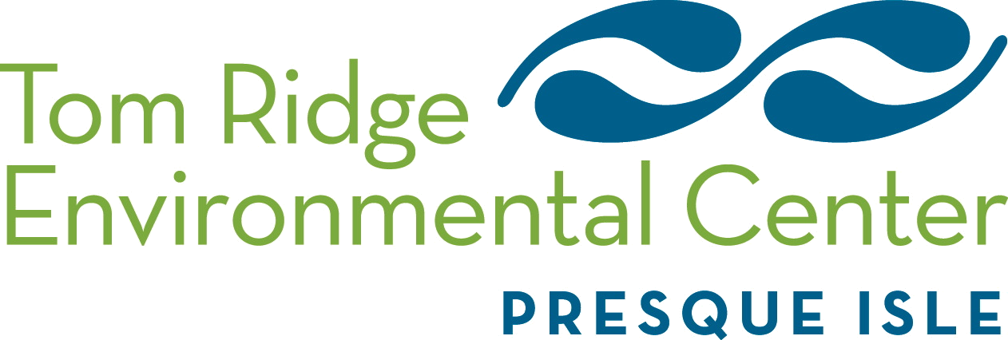


www.trecpi.org

Volunteer Position Descriptions
Volunteer Position Descriptions
Volunteer Position Descriptions
A. Archival Assistant
- Label collection materials in appropriate format.
- Enter collection information into cataloging database and organize into appropriate locations.
- Scan photos and slides into appropriate files.
- Organize maintain the TREC Library as needed and enter new items into the database.

B. Bus Tour Step-On Guide
- Provide groups with an interpretive tour of TREC and PI via bus.
- Provide information regarding the local area and attractions.
- Greet groups and direct them to their program site as required.

C. Pontoon Boat Driver
- Prepare boat for rides in the morning and secure it after the last ride in the afternoon.
- Operate pontoon boat and give interpretive talk for the general public.
- Ensure that each rider is adhering to the safety regulations set forth by the Coast Guard with regard to PFD usage.

D. Pontoon Boat Dock Assistant
- Open sign up window at 10 a.m., set out signup sheets.
- Assist visitors with choosing a ride.
- Assist the driver with distributing PFDs and loading/unloading passengers.

E. Roving Ambassador
- Provide information to visitors, such as maps, natural history info, and information on programs while driving, biking, walking, or kayaking throughout the park.
- Answer questions related to Presque Isle, Erie Bluffs, and the Erie Area.
- Conduct visitor surveys as needed.

F. TREC Docent
- Greet tour participants at scheduled times.
- Using lesson plans, facilitate tours of center and surrounding grounds for groups.
- Answer questions related to TREC, green building concepts, and other general info.

G. TREC Information Desk Attendant
- Greet all visitors, answer questions, provide program information, and provide information about the TREC, Presque Isle, and Erie Bluffs.
- Provide information regarding the local area and attractions.
- Greet groups and direct them to their program site as required.

H. TREC Garden Maintenance
- Assist in maintaining the gardens at the Tom Ridge Environmental Center.
- Weed out invasive plants.
- Prune and cut-back native plants and collect seeds.
- Pot excess native plants and seeds for preparation of the annual Native Plant Sale.
- Apply bark mulch and stone as directed.

I. Ranger Station Front Desk
- Keep track of visitors by using a counter
- Record information in the volunteer communication log
- Greet all visitors, answer questions, provide information about park programs, The TREC, the Ranger station, PISP, and local area and attractions
- Maintain the brochure rack and poster boards inside and outside of the building
- Keep program posters and special events up to date
- Maintain the Hot chocolate machine and keep area presentable
- Maintain the fire place and bring in wood when necessary

J. Naturalist Assistant
- Assist the Naturalists with development and presentation of environmental education and interpretive programs, which could include nature walks, night hikes, pedals, paddles, and preschool classes.
- Work booths at events to provide park and program information.
- Make copies, laminate documents, and prepare materials for programming and displays.
- Organize and maintain supplies and materials for use in EE programs.
- Maintain bird feeders and assist with maintaining the aquatics lab.
- Adopt-A-Beach- a volunteer group that meets once a month to clean the beaches and document the findings.
- Weed Warrior- assist park staff removing the invasive species on the park.
- Other duties as assigned.

K. One-time Community Service/Volunteer Opportunities
- Must contact the park at least 2 weeks in advance.
- Individuals complete volunteer application. The leader of a group must complete the volunteer application for the group and provides an attached list of all participates.
- Possible group and individual projects include:
- Beach Clean Up
- Invasive Plant Removal
- TREC Garden Maintenance
- Trail development and maintenance

Volunteers are welcome to participate in park events such as Spring Clean Up, International Coastal Cleanup, Discover Presque Isle, TREC or Treat, TREC the Halls, and other large events.

