*NOAA is also the sole United States official voice for issuing warnings during life-threatening weather situations. NOAA's National Weather Service is the primary source of weather data, forecasts and warnings for the United States. Television weathercasters and private meteorology companies prepare their forecasts using this information.*

Legacy of the Weather Bureau

Few people are affected more by weather than the mariner. An unexpected change in the winds, seas, or visibility can threaten the safety of the vessel and its crew. Weather forecasting for mariners has grown significantly since the infancy of the Weather Bureau in 1870. The US Weather Bureau was originally a branch of the Signal Service, later the Signal Corps of the U.S. Army. The plans to develop a Weather Bureau was originated by a Professor Cleveland Abbe, director of the Mitchell Astronomical Observatory in Cincinnati Ohio. Professor Abbe was convinced it was possible to produce daily weather forecasts for the country. The Weather Service was originally designed for the benefit of navigation on the sea coast and on the Great Lakes. Soon their services were expanded to support railroad companies, farmers, and commerce. Meteorologists learned how to prepare maps showing air pressures, among other weather elements, based on reports from stations around the country and how to use these to make forecasts. The basic idea was to forecast areas of low and high pressure to continue moving in the same directions without gaining or losing strength. What began as a regional weather-warning network to prevent the loss of life and property in the Great Lakes region rapidly grew into a national weather service.

* In 1848, Joseph Henry, Secretary of the new Smithsonian Institution, suggested a system of weather observers across the continent, who would use the newly operational telegraph to "forecast" storms.
* By 1860, 500 stations, manned by volunteers, furnished daily telegraphic weather reports. This volunteer network was the start of something much larger.
* General Myer with the U.S. Army Signal Corps started a weather warning network of observers began on November 1, 1870. Three times daily, Army Signal Corps field stations telegraphed basic weather observations to headquarters in Washington, D.C. Once the Signal Corps made forecasts and rudimentary storm warnings, the information was distributed to observers, railroad stations, and available news media.
* Immediately attention was given to collecting observations from land and vessels at sea
* Predictions, called “probabilities” began February 19, 1871 with forecasts out for 24 hours
* May 1871 circulars went out requesting navigators and vessel owners to share tri-daily observations to be transmitted to the Weather Bureau when they arrived at port
* November 13, 1871 established a system of international exchange between the weather bureaus of Canada and the United States
* June 10, 1872 Wind Signals began “For expenses of storm signals announcing the probable approach and force of storms throughout the United State for the benefit of commerce and agriculture”. Storm flags and lanterns were stationed at more than 300 points on the Great Lakes and along the coasts. Storm warnings were issued by forecasters in Washington.
* 1881 state offices were being established
* July 1885 predictions were expanded to 36 hours
* 1887 weekly crop bulletins were issued
* 1888 the cold wave flag and many other weather signal devices were introduced
* 1890 St. Paul Weather Bureau office responsible for the Great Lakes
* In 1891, the Weather Bureau passed from military to civilian control and was moved to the Department of Agriculture
* 1894 a Chicago Weather Bureau office opened
* August 1898 forecasts made for 48 hours
* July 1, 1891 the Weather Service was moved from the military Signal Corps to the Department of Agriculture.
* 1902 wireless telegraphy allowed the distribution of daily weather forecasts to vessels
* 1904 the Weather Bureau turned over all coastwise telegraph supplies to the Navy Dept though storm warnings remained a responsibility of Weather Bureau offices. The Navy Dept also required all of their vessels to report observations back to the Weather Bureau
* 1908 the Weather Bureau began issuing forecasts of a week to ten days in advance for temperature and precipitation
* 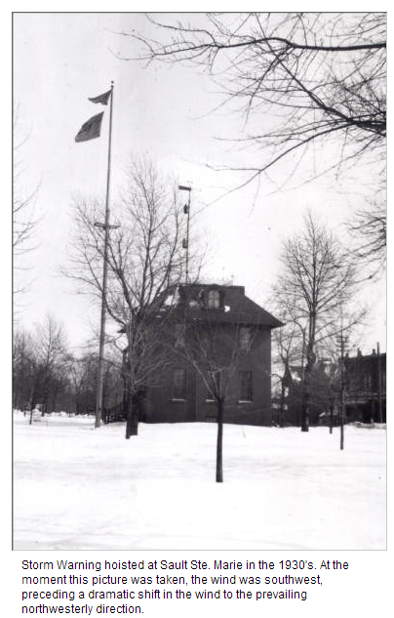In 1940, President Franklin D. Roosevelt transferred the Weather Bureau to the Department of Commerce.
* In the late 1950s and early 1960s, new tools such as satellites, computers, and high-speed communications made it possible to explore the physical environment across the globe.
* In 1970, the need for expanded environmental services, including improved weather forecasts and warnings, spurred the creation of NOAA within the Department of Commerce. The National Weather Service has been part of NOAA ever since.

*Storm warnings were delivered by Myer's patented "wig-wag" flag system. Upon receiving word by telegraph that a storm was heading their way, a flag was raised to warn the public about impending severe weather. Today, Myer's red flag with a black square in the center continues to warn coastal communities of impending tropical storms and hurricanes.*

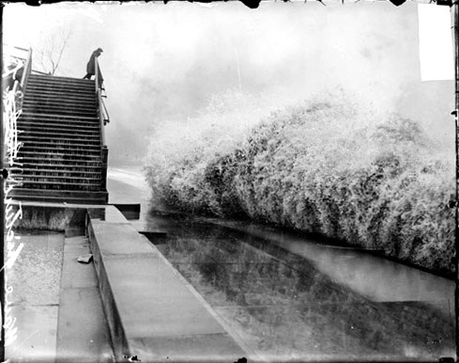

Picture of the Nov 13, 1913 “White Hurricane” On Lake Michigan. Location unknown. Source National Archives Digital Library Signal Corps

Modern National Weather Service

Today, NOAA manages a network of thousands of weather observations, made hourly and daily by government agencies, volunteer observers, ships, planes, automatic weather stations, and Earth-orbiting satellites. These observations provide the information to develop the weather forecasts and warnings we count on everyday.